YUMMY, YUMMY POPCORN
The 4Ps of Marketing

Product Specialist ____________________________________

Place Specialist ____________________________________

Promotion Specialist ____________________________________

Price Specialist ____________________________________

PLACE

PLACE DEVELOPMET

When thinking about PLACE, you will be considering the following:

What store(s) will this popcorn be sold in?
How will the popcorn get to the store (distribution)?
What aisle in the store will the popcorn be located?
What shelf in the store will the popcorn be on?
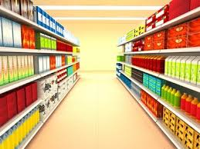
PLACE OBJECTIVE

Understand the 4Ps of marketing: Product, Place, Promotion, and Price

PLACE ASSIGNMENT

- List at least 10 ‘different’ store chains where you can sell your new popcorn:

- How will the popcorn be delivered to the store? Brainstorm and list or draw 4 or more ways to get the popcorn to the store:

- Of the choices listed in #2, which would be the best way to get your product to market?

- Shelf space is valuable real estate. The big companies pay money to the store in order to get the best places in the store and on the shelf. Shelf space that is at eye level is the best. However, you might not be able to afford having your product at eye level. Discuss with your team the best location on the shelf for your product and your budget. Write your decision here:

- If you decide to pay the store for a better shelf location, how much are you willing to pay? Check with the Price Specialist on your team to find this cost. This cost will be added to the price of the product. You can always come back and change your answer for this question later.

- Draw the aisle in the store AND the shelf where you would place the new popcorn. Be sure to include the products that would be around your popcorn. You need to know the competition around you. Also, in your drawing, label how much shelf space you will need in inches?

